National University of Computer and Emerging Sciences



Lab 06

Coal

|  |  |
| --- | --- |
| Name | Muhammad Zain |
| Roll No. | 19F-0228 |
| LAB INSTRUCTOR | MR ABUZAR GHAFARI |
| Semester | Fall 2020 |

Task 1

# **Source Code**

*; Author :Muhammad Zain*

; Program Name :Hexa to decimal

; Program No :Task 1

; Lab number :lab 6

; Date 11-11-2020

INCLUDE Irvine32.inc

.data

main_msg db "Enter Hexadecimal Number ",0

output_msg db "Hexadecimal to decimal equal ",0

output dword 0

.code

main PROC

;calling input funtion

call input

;calling convertion function

call convert

; output

mov edx,offset output_msg

call writestring;output msg

call crlf ;next line

mov eax,output ;store result

call writeDec ;show it

exit

main ENDP

;==========================================

;first we write string

;then we take input

;then we return it

;==========================================

input proc

mov edx,offset main_msg

call writestring ;writing main string

call Readhex ;read hex because we need hexadecimal value

mov cl,0

input endp

;===================================================

;this is convertion function

;first we will shift one right

;then we check if condition what is in CARRy

;then we perform shifiting

;=====================================================

convert proc

.WHILE eax != 0

shr eax,1

.IF CARRY?

mov ebx,1

shl ebx,cl

add output,ebx

.ENDIF

add cl,1

.ENDW

ret

convert endp

END main

# **Snip**

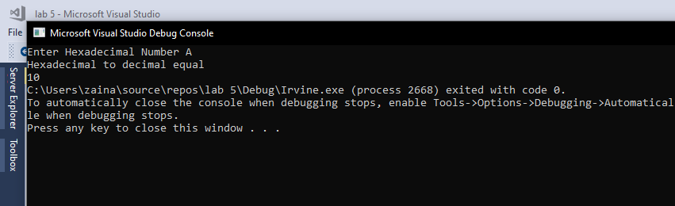

Task 2

# **Source Code**

*; Author :Muhammad Zain*

; Program Name :Bitwise multiplication

; Program No :Task 1

; Lab number :lab 6

; Date 14-11-2020

INCLUDE Irvine32.inc

.data

main_msg db "Enter 1st Number = ",0

main_msg_2 db "Enter 2nd Number = ",0

output_msg db "Bitwise multiplication = ",0

output dword 0

.code

main PROC

;calling input funtion

call input

;calling convertion function

call Multiplication_Function

; output

mov edx,offset output_msg

call writestring;output msg

; call crlf ;next line

mov eax,output ;store result

call writeDec ;show it

exit

main ENDP

;==========================================

;first we write string

;then we take input

;then we return it

;==========================================

input proc

mov edx,offset main_msg

call writestring ;writing main string

call ReadDec ;read dec because we need decimal value

mov ebx,eax

mov edx,offset main_msg_2

call writestring;writing main string for second input

call ReadDec ;read dec because we need decimal value

mov edx,ebx

ret

input endp

;===================================================

;this is multiplication function

;first we will shift one right

;then we check if condition what is in CARRy

;then we perform shifiting for multiplication

;=====================================================

Multiplication_Function proc

mov cl,0

.WHILE eax != 0

shr eax,1

.IF CARRY?

mov ebx,edx

shl ebx,cl

add output,ebx

.ENDIF

add cl,1

.ENDW

ret

Multiplication_Function endp

END main

# **Snip**

